**TITLE OF RESEARCH (TNR, 14pt, bold, centered)**

Author1*, Author2 (TNR 14pt centered) and Author3

1Institution 1(TNR 11pt centered)

2Institution 2 (TNR 11pt centered)

3Institution 3 (TNR 11pt centered)

*E-mail (corresponding author)



# ABSTRACT (TNR, 11pt, Bold, Centered)

A brief abstract summarizing the research, its objectives, methods, results, and conclusions. (TNR, 11pt justify)

*Keywords:* Keyword 1, Keyword 2, Keyword 3



# INTRODUCTION (headlines: TNR, Bold, 11pt)

The introduction should provide a background to the study, outlining the research problem, objectives, and significance. It should introduce key concepts and context, highlight the gap in the existing literature that the study aims to fill, and briefly state the research questions or hypotheses. (TNR, 11pt, justify)

# LITERATURE REVIEW (headlines: TNR, Bold, 11pt)

The literature review provides an overview of existing research related to the study's topic, introducing key concepts, theories, and models while synthesizing major findings from previous studies. (TNR, 11pt, justify)

# SUB TOPIC 1 (headlines: TNR, Bold, 11pt)

Any related topic (TNR, 11pt, justify)

# SUB TOPIC 2 (headlines: TNR, Bold, 11pt)

Any related topic (TNR, 11pt, justify)

All the tables, images and figures should be centered. Figures and images should be numbered and figure headers should be placed under the figure or image; as for the tables, they should also be numbered and the table header should be placed at the top. References (if any) of the tables, figures and images should be presented right under the tables, figures and images in the form of author surname and publication date. (TNR, 11pt, justify)

1. Equations

Equations should be centered and numbered consecutively, as in Eq. [1]. An alternative method is given in Eq. [2] for long sets of equations where only one referencing equation number is wanted.

(1 line spacing here)

|  |  |  |
| --- | --- | --- |
|  |  | [1] |
| where, | (1 line spacing here) |  |
|  |  | [2] |

1. List

Lists can be provided using either numbers or bullets:

1. List item 1 like this;
2. List item 2 is an example of a longer list item that wraps to a second line, where the second line is indented.

The example for bulleted items like this:

* List item 1;
* List item 2.

1. Tables and figures

Tables and figures should appear in one column of a page and be numbered consecutively. Figures and texts may appear on the same page, and a centered caption should appear directly beneath the figure. It is preferable that figures be mounted in portrait style and figure captions are no longer than two lines. On figures showing graphs, both axes must be clearly labeled (including units if applicable).

Tables should be designed to have a uniform style throughout the paper, following the style shown in Table 1. Table captions should be in 10pt “Time News Roman” bold, centered, and the texts in Table should be set in 9pt “Time News Roman” font.

**Table 1. Caption heading for a table should be placed at the top of the table and within table width.**

**(**Use “time news roman” font, size 10pt, No spacing after table title)

|  |  |  |  |  |
| --- | --- | --- | --- | --- |
|  | **A** | **B** | **C** | **D** |
|  |  |  |  |  |
| **A** | Aa | Ab | Ac | Ad |
| **B** | Ba | Bb | Bc | Bd |
| **C** | Ca | Cb | Cc | Cd |
| **D** | Da | Db | Dc | Dd |
| **E** | Ea | Eb | Ec | Ed |
|  |  |  |  |  |

Authors are advised to prepare their figures in either black and white or color. Please prepare the figures in high resolution (300 dpi) for half-tone illustrations or images. Pictures must be sharp enough otherwise they will be rejected. Figures must be originals, computer-generated or drafted, and placed within the text area where they are discussed. Figure 1 shows one example. Figure captions should be in 10pt “Time News Roman” font, bold, centered. When applicable, the texts in graphs, illustrations or images should be set in 8pt “Time News Roman” font.

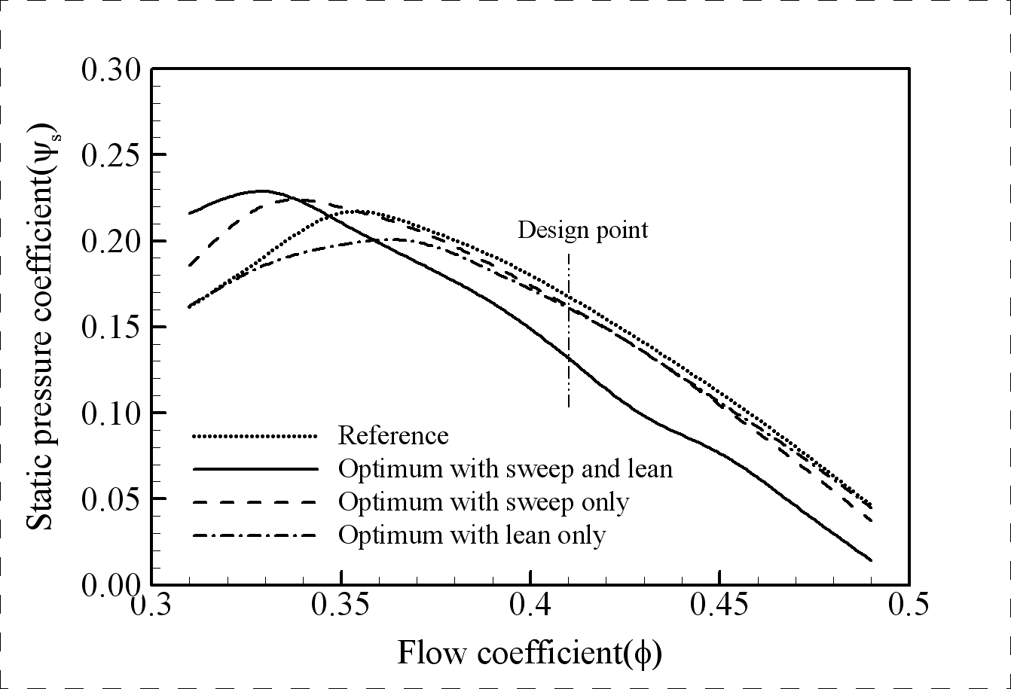

**Figure 1. The caption heading for a figure should be placed below the figure and within figure/illustration width. (Use “Time News Roman” font, size 10pt, no spacing between title and figure)**

1. Units

Use either SI (MKS) as primary units. English or CGS units may be used as secondary units (in parentheses). Avoid combining SI and CGS units. This often leads to confusion because equations do not balance dimensionally. If you must use mixed units, clearly state the units for each quantity that you use in an equation. Do not mix complete spellings and abbreviations of units. Spell out units when they appear in text.

# CONCLUSION (headlines: TNR, Bold, 11pt)

Conclusions should include (1) the principles and generalisations.

# REFERENCES (headlines: TNR, Bold, 11pt)

References should be listed arranged in alphabetical order beginning with the author’s names and initials, followed by the year of publication, title of periodical, volume and page (APA style).

**In the text, references should be cited with the name of the author(s) with the year of publication in parenthesis, e.g., Philip (1957), Taylor and Baker (1986), Smith et al. (1987).**

Example:

Agag, G., & El-Masry, A. A. (2016). Understanding consumer intention to participate in online travel community and effects on consumer intention to purchase travel online and WOM: An integration of innovation diffusion theory and TAM with trust. *Computers in human behavior*, *60*, 97**-111.**

George, D. & Mallery, M. (2010). SPSS for Windows Step by Step: A Simple Guide and Reference,

17.0 update (10a ed.) Boston: Pearson.

Malaysian Communication and Multimedia Commision. (2020). Internet Users Survey 2020. ISSN 1823- 2523 Retreive September,2021 from https[://www.mcmc.gov.my/skmmgovmy/media/General/pdf/IUS-](http://www.mcmc.gov.my/skmmgovmy/media/General/pdf/IUS-) 2020-Report.pdf

Simon Kemp. (2021). Digital 2021: Malaysia. Retrieved November 11, 2021, from https://datareportal.com/reports/digital-2021-malaysia

Singh, S., & Srivastava, P. (2019). Social media for outbound leisure travel: a framework based on technology acceptance model (TAM). *Journal of Tourism Futures*.